UNEG NECD Working Group session at gLOCAL: “What really makes an evaluation country-led?”
Two polls were included in the session – the first one asked: what word comes to mind when we say “country-led evaluation”?
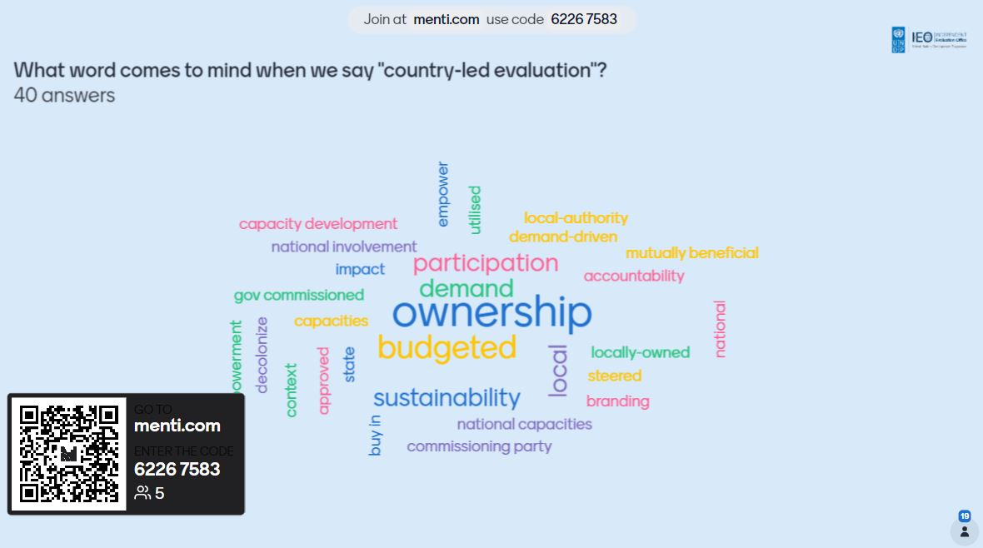
The second a poll that asked participants to rate the relevance of six points:

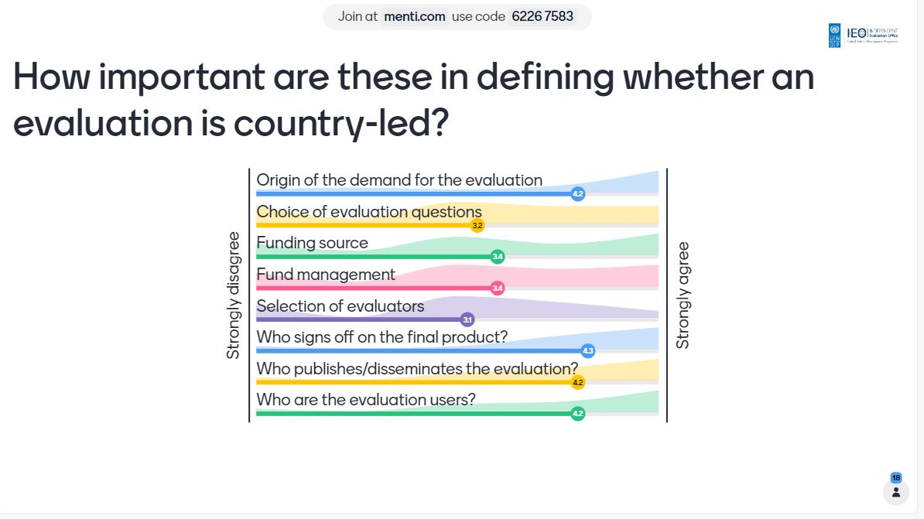
The MIRO board captured some key themes:
