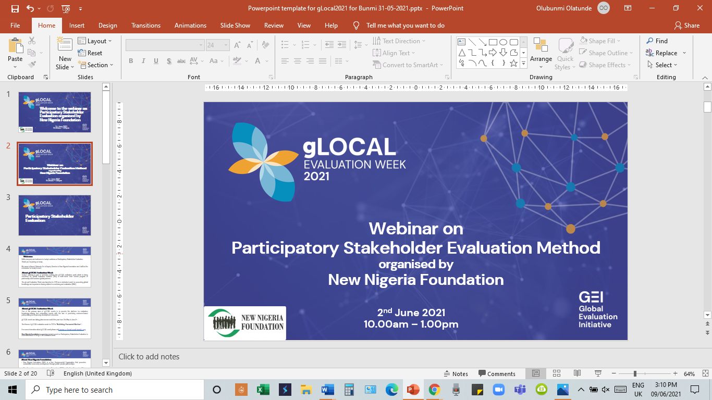

Report of gLOCAL Evaluation Event

2021

Introduction
Several countries around the world celebrated the gLOCAL Evaluation Week from 31st May to 4th June 2021 with a focus on the theme ‘Building Forward Better’. Global Evaluation Initiative (GEI), a multi-donor trust-funded program, in partnership with local and global partners convenes the gLOCAL Evaluation week annually. The event aims to promote knowledge-sharing and networking on monitoring and evaluation to enhance evidence-based policymaking and improved development outcomes. The gLOCAL Evaluation Week was launched in 2019 as a dedicated week for promoting global knowledge and experience sharing related to monitoring and evaluation.

Webinar Proceedings
New Nigeria Foundation’s proposal was among the successful proposals approved to host the gLOCAL event in Nigeria. The Foundation proposed to promote knowledge and experience sharing on Participatory Stakeholder Evaluation (PSE) method. The event was held on Wednesday, 2nd June 2021, involving a webinar comprising a training and panel discussion on Participatory Stakeholder Evaluation (PSE) method. A total of 193 people registered for the event, while 63 people participated in the event. Participants that registered comprised 46.6% females and 52.8% males from different sectors such as civil society, private sector, government, academia and research institutions. The virtual event lasted about 2.5-hours and was transmitted live through the zoom platform and streamed on NNF’s YouTube channel.

In the first session, Prof. Obafemi Ajibola, Managing Director of NNF, facilitated the training on Participatory Stakeholder Evaluation (PSE). Participants learnt approaches for conducting participatory evaluation; advantages and disadvantages of using PSE; process for undertaking PSE, critical decisions to be made on the PSE process and requirements for successful implementation of PSE.

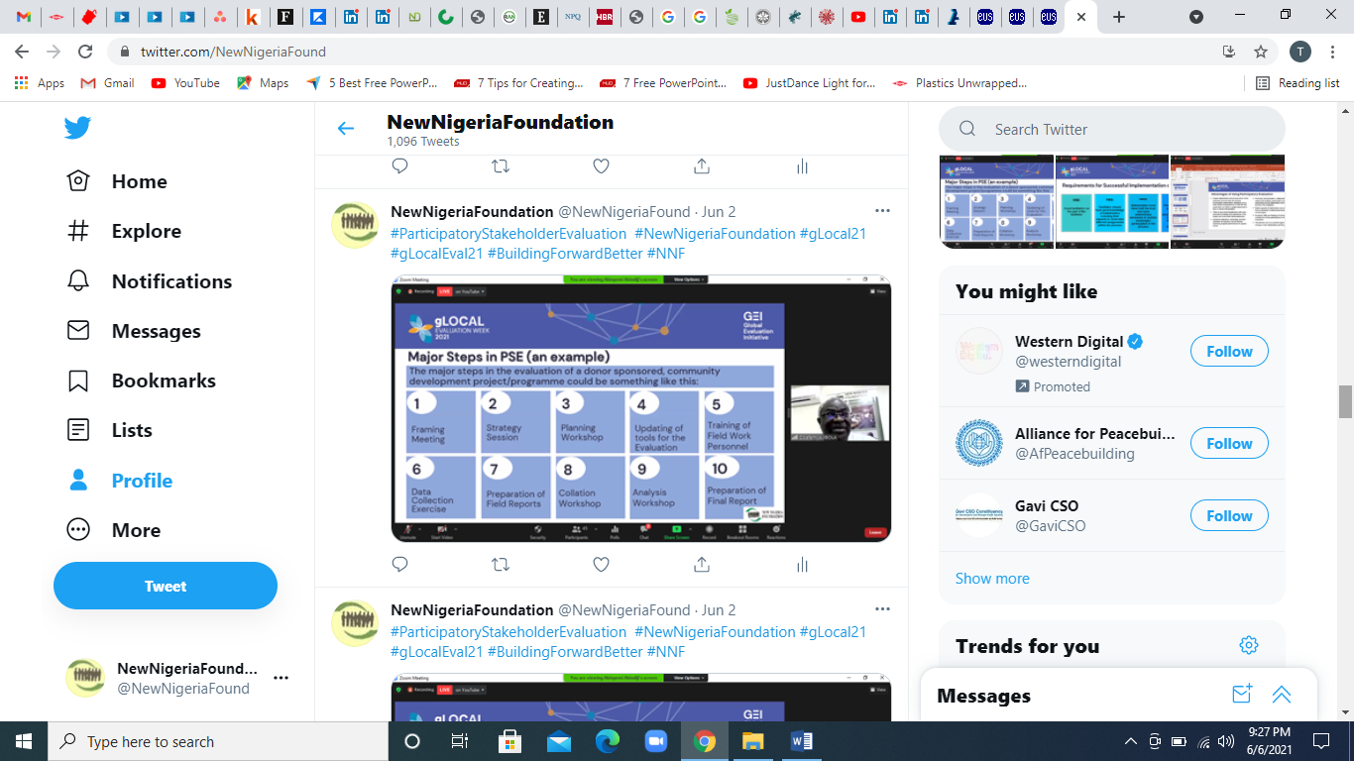
Screenshot of gLOCAL Tweets

The second session featured a panel discussion involving three panellists who shared experiences on the use and benefits of the PSE method. The panellists were Mr Sam Daibo (Area Manager, Policy Government and Public Affairs Field Operations, Chevron Nigeria Limited); Dr Dara Akala (Executive Director, Foundation for Partnership Initiatives in the Niger Delta); and Mrs Olayide Adesanya (Deputy Director and Head of Programmes, New Nigeria Foundation). NNF’s Bunmi Olatunde (Deputy Director) moderated the virtual event. Panellists spoke about their organizations’ rationale for choosing the PSE method, how different stakeholders (government, CSOs, development practitioners, private sectors, academic and research institutions) benefit from adopting PSE, and examples of ways their organisations benefited from using PSE and the challenges experienced.



Participants who had implemented the PSE method were also encouraged to participate in discussions on building forward better using the PSE method and how PSE can be conducted post-COVID-19.

The audience also participated in the question-and-answer session. The panellists took turns answering participants’ questions which included the following:
- How can you get stakeholders that are rural farmers to participate in the PSE process since they are more interested in the project benefits rather than the processes involved in project management?
- What are the critical factors to considering when preparing for the planning workshop?
- Is it mandatory to share the PSE report with all stakeholders? How can PSE implementers bridge the gap between data analysis and when the report will be shared with the stakeholders?
- In promoting rural economy via agribusiness, how does PSE apply?

Key Takeaways from the Webinar

Some of the key takeaways from the training and panel discussions are:
- Participatory Stakeholder Evaluation (PSE) is an approach that promotes the active involvement of stakeholders in the evaluation process.
- Three major evaluation approaches that promote stakeholder involvement are Collaborative Evaluation, Participatory Evaluation and Empowerment Evaluation.
- Stakeholder involvement is a very important concept in development. It is important to involve stakeholders in designing, managing and evaluating projects and programs.
- The Participatory Stakeholder Evaluation (PSE) method promotes communication, collaboration, relationship building, partnerships and networking among stakeholders beyond the evaluation.
- An advantage of PSE is that there is input from beneficiaries with more personal knowledge and experience of the project and local needs being addressed.
- A disadvantage is that PSE requires the use of a skilled facilitator for conducting the multi-stakeholder processes, capacity building and conflict resolution.
- PSE requires a lot of resources including funding, time and commitment of many stakeholders.
- By using PSE, Chevron Nigeria Limited was able to engage directly with stakeholders, had a deeper understanding of the needs of stakeholders, achieved stakeholder ownership of the GMoU process and made informed decisions resulting in the improvement of CNL’s GMoU model.
- PIND Foundation benefitted from using the PSE method in many ways including learning and knowledge retention in the organization and staff engagement with the organization’s extensive networks.
- By using the Participatory Stakeholder Evaluation method for its institutional assessment, NNF was able to gain the trust of its stakeholders who had the impression that NNF is a transparent and accountable organization.

Poll Survey
Participants responded to 3 poll questions which provided information about the number of participants that knew about PSE, had been involved in implementing PSE, and whether participants increased knowledge from the webinar. The results of the survey are as follows:

Participants that have participated in a Participatory
Stakeholder Evaluation process

Participants familiar with the Participatory Stakeholder
Evaluation method

Participants that gained more knowledge about Participatory Stakeholder Evaluation from the webinar

66%
67%
100%

Conclusion
The webinar was successful in achieving its objectives. All participants confirmed that they increased their knowledge of the Participatory Stakeholder Evaluation method. The training and panel discussions were robust and engaging and participants participated actively in the discussions.

Appendices

Appendix 1: Evaluation of the NNF gLOCAL Event

Only 19 out of 63 participants completed the evaluation form. The responses are summarized as follows:
- Have you previously attended events during gLOCAL Evaluation Week in 2019 and 2020?
None of the respondents attended events during gLOCAL Evaluation Week in 2019 but one of the respondents attended events during gLOCAL Evaluation Week in 2020.

2. Did you attend this event?
Only one of the respondents registered but did not attend the event. The respondent hopes to watch the recording.

3. Rate the overall quality of this event
Respondents rated the quality of the event: Excellent (28%), Very Good (61%) and Good (11%).

4. How relevant was this event to your job?
Respondents rated the relevance of the event to their job as such: Extremely Relevant (68%) and Relevant (32%).

5. How did you benefit from participating in this event? (*Participants gave multiple answers)
Respondents benefited from the event in the following ways:
- 13 respondents increased capacity to support monitoring and evaluation;
- 12 gained technical knowledge;
- 11 increased awareness;
- 3 shared technical knowledge; and
- 3 respondents built new connections.

6. Which of the following evaluation topics interest you the most?
Respondents gave multiple responses to the question on evaluation topics of interest:
- 12 respondents indicated Evaluation Methods;
- 11 respondents indicated Evaluation Capacity Development;
- 10 respondents indicated Generation and use of evaluation;
- 10 respondents indicated Evaluation Communication; and
- 4 respondents indicated Evaluation 2030.

7. By what means did you find out about this event? (*Participants gave multiple answers)
Respondents found out about the event through the following means:
- 10 reported Professional networks;
- 6 said Email or Listserv;
- 2 indicated Twitter;
- 1 said The CLEAR Initiative;
- 1 said Facebook; and
- 1 respondent said The Global Evaluation Initiative (GEI).

8. Scope of respondents’ organization's work? (Location of people served)
Respondents indicated the scope of their organization’s work as: Sub-National or Regional (10), National (12), International (2). (*Participants gave multiple answers).

9. Suggestions to help improve gLOCAL Evaluation Week in the future.
- The inclusion of community representatives who have benefited from the PSE process would be beneficial.
- Invite government officials and elected individuals to participate in the webinar.
- A very good initiative. I would suggest that notice of the gLOCAL evaluation week is published on time and with a wider spread; also, that more discussants and topics be incorporated.
- Conduct more sessions and topics in Monitoring and Evaluation. Explore how the Governments in Nigeria can benefit from the webinar and deploy the techniques in public service programming.
- Use the best internet connection to improve the quality of the webinar broadcast. During Professor Ajibola presentation, he was sometimes out-of-sync due to network issues.
- Introduce a bill to get the government to incorporate Participatory Stakeholders Evaluation (PSE) as a method to engage citizens before designing or evaluating projects and programs.
- It was excellent.
- I hope I can get to watch the recording.
- Conduct more training on Monitoring and Evaluation.

Appendix 2: Testimonials from Participants

The following are some testimonials of participants about the event:

“The program reinforced the critical role Participatory Stakeholders Evaluation plays in in organizational and national development.” - Anonymous participant

“It was enriching and insightful. I gained from the experience sharing of the panellists. I also had a deeper insight on the usefulness of PSE as a veritable tool to get the buy-in of citizens in the context of wider governance.” – Fisayo Alo

“I was exposed to the many advantages of the Participatory Stakeholder Evaluation method. I understood some of the processes involved in conducting in a successful Participatory Stakeholders Evaluation process.” – Lydia Ndieze

“I gained from the presentation on Participatory Stakeholder Evaluation and the panel discussions. It ties into how we (CNL) engage under GMoU/OMoU and PSA working with NNF and our stakeholders. It has helped with our decision process for our engagements and social investment implementation. With the stakeholder feedback it provided, it has helped us to secure social license to operate in the extractive industry and ultimately added to the bottom line.” - Charles Egbuedo

“gLOCAL Evaluation Week was so helpful to me as an individual for the technical knowledge gained during the event. For us as a company, it is part of capacity building and development, and to us as a nation (Nigeria), the event will serve as a base for policy formulation by our policymakers.” - Anonymous participant

“The event has enriched my technical knowledge of M&E.” - Anonymous participant

“This event helped me understand more and increased my knowledge on the technicality of M & E.” Anonymous participant

Appendix 3: Comments of Participants in the Chat Box

Some of the comments of participants in the chat box are:

Liz Orage: Brilliant presentation by Prof. Obafemi Ajibola. Very educative.

Chichi: Very insightful and practical presentation. Thank you, Prof Ajibola.

Innocent Arike: This is an excellent presentation and an eye-opener to some of us. Thank you for this great presentation.

Lydia Ndieze: The PSE will help politicians truly understand peoples’ perspective in terms of developmental needs and what works best for their overall wellbeing. If these then form the basis of the Politicians policy trust and project design and implementation pursuit, then the states will achieve appreciable progress and beneficial developmental strides.

Toyin Akpan: Thanks for asking for our reflections. I believe that strategies such as Town Hall meetings and Open sessions at the Senate and Houses of Assembly and Representatives can be structured to adapt PSE to gauge the performance of various aspects of governance including policies and strategies of government.

Chichi: Leadership is more successful when it is a collective effort. Policymakers cannot deliver good results without the participation of the persons they are leading or representing. Therefore, PSE is an excellent tool to foster that sense of collective ownership and leadership as it allows the critical stakeholders to contribute to leadership actions and decisions that directly meets their needs. If acted on, the outcomes will be co-owned and are more assured of delivering services that will positively improve the lives of the citizens. PSEs make citizens active participants in governance.
Caleb Wanga: Participatory evaluation strengthens democratic governance in many aspects. Here in Kenya, we have devolution as a strategy for enhancing the delivery of services where public participation has been made mandatory.

Yemisi Ransome-Kuti: Former Governor Fashola organized participatory monitoring of projects in Lagos State. This tradition should be institutionalized.

Fisayo Alo: It is an understatement that Nigeria needs a PSE urgently. The challenges of the country point to this but the issue to contend with will be the political will to conduct such a process and then implement its outcomes. A case in point is the ongoing Senate review of the 1999 constitution which will go a long way if it followed a process like PSE.

Chiekezi Opara: The method should be considered during intervention design and not as an afterthought (since it is resource consuming). - Stakeholder identification and mapping during design is also important.

Lydia Ndieze: Despite the Covid-19 pandemic, stakeholder engagement is still the way to go. The question is how do we manage the expectations of the varied groups? Get the right facilitator with the ability to manage the varied expectations; Do online and not so much of onsite group meetings, and get the general focus and guidelines of the forum well spelt out.

Princess Umoh: Stakeholders are an integral part of our success in the development sector. However, not all stakeholders are conversant with virtual meetings l still think face-to-face meetings are better to achieve the desired results.

Olayinka Bajomo: This webinar is an eye-opener. I have been educated on what PSE is all about and so empowered to work with various communities I am involved with. Thanks to the organizers, speakers, moderator and other contributors.

Happy Apai: Interactive session. Well-done!

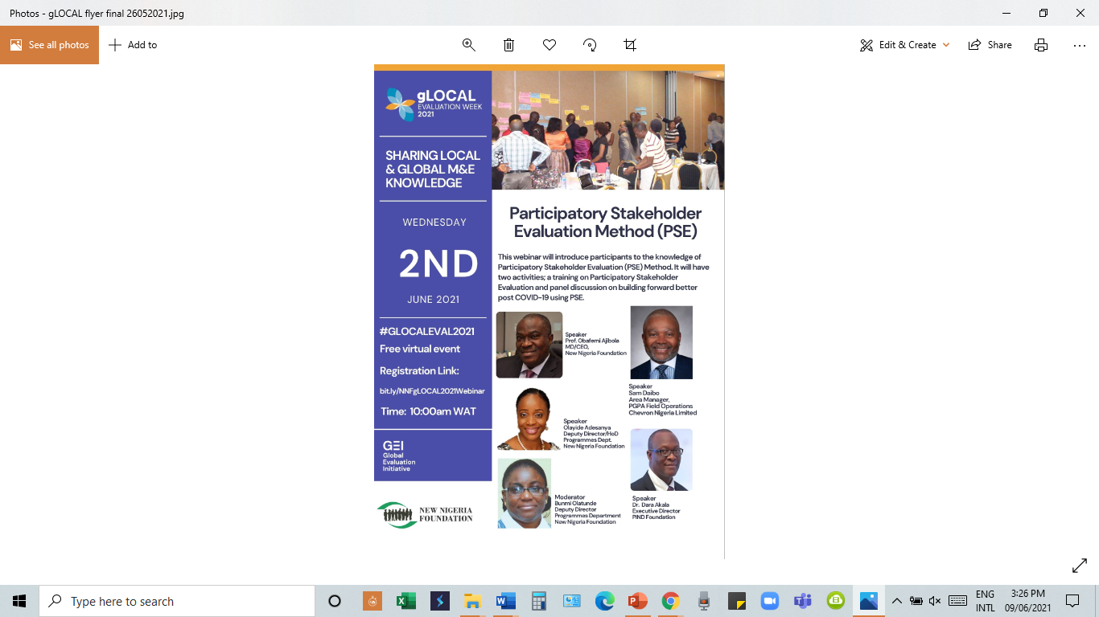
Appendix 4: gLOCAL Flyers

